**Difference between web based, client-based, enterprise and console-based application:**

**Web based application**: Uses web browser as its interface/Client. E.g.: JQuery, python, pearl

**Enterprise based application**: Used for business purpose. Used in organisations.

E.g.: SAP

**Console Based application**: Console applications are light weight programs run inside the command prompt (DOS) window. They are commonly used for test applications.

**Console-based applications** include Alpine (an e-mail client), cmus (an audio player), Irssi (an IRC client), Lynx (a web browser), Midnight Commander (a file manager), Music on Console (an audio player), Mutt (an e-mail client), nano (a text editor), ne (a text editor), newsbeuter (an RSS reader), and ranger (a file manager).

**Client-Based application**: An application that runs on the client side and accesses the remote server for information is called a client/server application.

The client server always makes requests to the remote server to get some information. The user interaction with the server is always through a user interface or application on the client side. The user interaction in a web application is through a web browser. A client server application can be platform specific as well as cross platform depending on the programming language used.

**Library management system:**

Requirement Gathering:

* The member should be able to access any book anytime.
* Each book has unique number.
* Based on the unique number, we can find in which row it is placed.
* The library system contains information on the members. Like what are the number of the book checked out by the member. When is the book due etc.
* There should be a maximum and minimum limit on how many books can be borrowed.

Analysis:

* It checks if the member making the request, is registered in the database or not. And also, if it is authorised or not.
* There are various module- search module(where user can find any book), security module(user need to login to the system), Borrow item module(so the user can borrow the item) and return module.

Design:

* A database is created.
* Use case diagram:

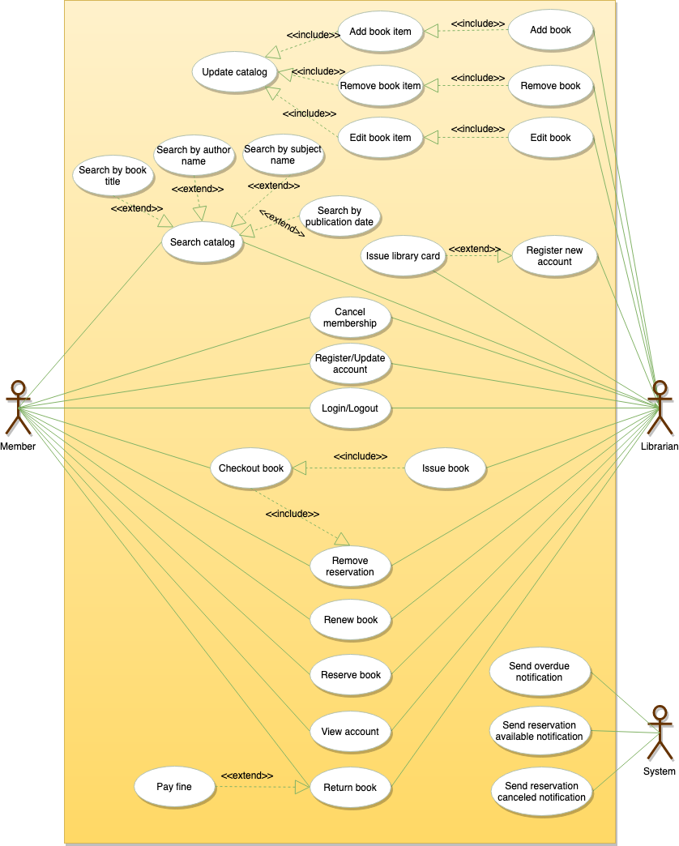

Coding and testing:

* Code is written which makes changes into the database informing when a book is borrowed, when is the return date.
* Code is also written to check in the database if a user has any fine due.
* Code is written to check if the user has exceeded the limit of borrows.
* Languages used